North East Authorities
Governance Review

Undertaken in accordance with Section 111 of the Local Democracy Economic Development and Construction Act 2009

Contents
Executive summary 3
Purpose of review 6
Methodology for the Governance Review 7
North East Devolution Ambitions 8
North East context 10
A functional economic market area 11
North East Economy 13
Understanding current governance arrangements 23
Case for change 27
Criteria 32
Governance options 34
Conclusions 38
Annex A: The “Minded To” Deal 40
Annex B: The Draft Scheme for Publication 41

Executive summary
On 28 December a “minded-to” devolution deal was agreed between government and the local authority leaders of Durham County, Gateshead, Newcastle City, North Tyneside, Northumberland County, South Tyneside and Sunderland City Councils.
The deal agrees a significant shift in powers, funding and responsibility from Whitehall to the region in return for establishing the role of a directly elected Mayor for the area of the North East.
The additional powers and funding within the deal include a £1.4bn investment fund, alongside funding for skills, transport, education and skills, housing and regeneration. We estimate that the overall value of the deal will be £4.2bn. This will enable investment into projects which reflect local needs and opportunities, making a real difference for our residents, communities, and the local economy.
The purpose of this governance review, undertaken in accordance with Section 111 of the Local Democracy, Economic Development and Construction Act 2009 [the 2009 Act] is to look at the exercise of statutory functions in the North East with a view to deciding whether to prepare and publish a scheme with new functions and changed constitutional arrangements, including a directly elected mayor for a combined authority across the whole area. A public consultation would then be carried out on the proposals set out in the scheme. The Secretary of State would then be provided with a summary of consultation responses and would need to consider whether an order should be made under the 2009 Act to establish a Mayoral Combined Authority [MCA] for the area.
Under Section 112 of the 2009 Act, the review needs to conclude that the exercise of the power to make an order to establish an MCA for the North East area would be likely to: improve the exercise of statutory functions in relation to the North East area; help secure more effective and convenient local government; and reflect the interests and identities of local communities.
The review has found that the economic evidence provides a rationale to build on existing collaboration, delivery and success by creating a new Mayoral Combined Authority to exercise powers to grow the whole North East economy. In doing this, it would have responsibility to develop the people, communities and businesses it serves across the whole region. The new Mayoral Combined Authority would replace the existing North East Combined Authority [NECA], which covers Durham County, Gateshead, South Tyneside and Sunderland, and the North of Tyne Combined Authority [NTCA], which covers Newcastle City, North Tyneside and Northumberland County. Together with the North East Local Enterprise Partnership [North East LEP] and Transport North East, these organisations have significant existing capabilities and technical expertise which can be utilised by the new MCA.
The NTCA, NECA, North East LEP and Transport North East have overseen programmes of investment which have secured thousands more jobs, supported hundreds of residents into employment and seen major investment in infrastructure. Nevertheless, by working at a wider geography there is the opportunity to not just deliver more for the region but to also better-meet the needs of the regional economy, where supply chains and commuting patterns stretch out over a wide geography.

Despite significant economic successes and assets, the North East is still a net spender of UK tax revenues and there are ongoing challenges in relation to securing the region’s ambition to promote faster and more inclusive growth, tackle the climate emergency and deliver an integrated transport system fit for the 21st Century. And there is not enough local control over the policies that affect our economy.
The North East deal will unlock significant long-term funding and give local leaders greater freedom to decide how best to meet local needs and create new opportunities for the people who live and work here. The government recognises that devolution is a journey, not a one-off event. The agreement is the next step in a process of further devolution. As institutions mature, they can gain greater responsibility, and the North East will be able to deepen the devolution arrangements over time, subject to government agreement. The government will continue to work with the North East on important areas of public service reform and infrastructure investment, to support inclusive economic growth in towns, cities and rural areas whilst tackling climate change, on our journey to a net zero green economy.
The review concludes that:
- Current regional governance arrangements – based on a combination of a Mayoral and a non-Mayoral Combined Authority and a Joint Transport Committee (through which the combined authorities exercise transport functions) – do not represent the best model in terms of delivering the long- term ambitions of the local authorities within the area for economic growth and delivery of public services. Currently, the Combined Authorities have responsibilities for creating the conditions for economic growth and new investment in the area, with the NTCA also having additional powers and funding to support inclusive growth, housing and skills. The Joint Transport Committee was established to provide policy direction and governance to transport matters across the whole of the North East area.
- The new Authority would extend the benefits of devolved funding for investment, skills and housing, previously secured by the North of Tyne MCA, over the full regional geography. In addition, it would unlock new funding and powers, including over transport, across the whole region.
- There is limited practical scope for the existing governance arrangements to be meaningfully strengthened, short of adopting the Mayoral Combined Authority (MCA) model of governance.
- A change is required to enable the North East authorities to pursue their economic and social policy agenda at greater pace, while continuing to collaborate with Tees Valley, Cumbria and southern Scotland.
- The statutory criteria for preparing and publishing a scheme are met, i.e. the making of an order under the 2009 Act, to enable the adoption of an MCA model of governance for the area of the North East, will likely improve the exercise of statutory functions in that area.
- In addition, with regard to the criteria which the Secretary of State would need to consider before making such an order, it is considered that establishing a MCA model of governance for the North East will:

  - Have a positive impact on the interests and identities of local communities – these proposals build on established regional governance arrangements, longstanding and productive collaboration over a functional economic area and which represent the views and interests of the local community; and
  - Secure more effective and convenient local government by reducing complexity and streamlining the delivery of public services within the area.

It is therefore proposed that a scheme is published (a draft scheme is included at Appendix B) that confirms:
- A new MCA should be created to cover the area of the North East, replacing the existing NTCA and NECA organisations;
- A North East Mayor would be elected in May 2024;
- The Mayor would be a member of the Combined Authority and chair meetings of the authority;
- Each Council will appoint a member to the new MCA, alongside non-voting members representing business and the community and voluntary sector; and
- The Mayor and MCA will exercise statutory functions, and hold some powers concurrently with the North East local authorities. No functions are being removed from those councils. Where existing functions currently held by North East local authorities are to be shared with the Mayor or the MCA, this must be agreed by the constituent councils.

Upon establishment, the initial objectives for the new MCA will include:
- Creating an additional 24,000 jobs;
- Building an additional 3,100 homes;
- Helping 6000 people to get “work ready” each year;
- Commissioning 70,000 courses each yet to get people good jobs;
- Taking major steps to Net Zero; and
- Leveraging £5.0bn of private sector investment.

Purpose of review
North East Leaders and Mayor have agreed with Government that fulfilling the local economic priorities and drawing down significant additional powers and funding through the North East Devolution Deal would create new opportunities for the area. However, seeking to maximise these opportunities for the area raises questions about the on-going appropriateness of regional governance arrangements which are currently based on the North East Combined Authority (non-Mayoral), the North of Tyne Mayoral Combined Authority, the North East LEP, and the Joint Transport Committee. As part of the deal, Leaders and Mayor have committed to consider the creation of a new, directly elected North East Mayor, acting as Chair to the North East Mayoral Combined Authority by May 2024.
The seven councils, along with the two combined authorities, have therefore commissioned this review to look at whether strengthening existing collaboration arrangements by adopting a single MCA model of governance would be the best way of creating more inclusive and cleaner growth and improving delivery of transport functions.
To ensure compliance with the relevant legislation contained in the 2009 Act, the Review considers whether an MCA is the best governance model that would be likely to
- Improve the exercise of statutory functions in the area of the North East

Secure more effective and convenient local government for the area; and
- Have a positive impact on the identities and interests of our local communities.

Methodology for the Governance Review
The Governance Review has comprised the following:
- The North East’s ambition and context, covering the area’s devolution journey and devolution deal
- An economic assessment of
  - The existence of a Functional Economic Market Area across the North East; and
  - The region’s economic strengths, challenges and opportunities
- An assessment of the current governance arrangements across the North East
- The case for change
- The devolved functions in scope
- An options appraisal that considers the alternative governance structures which could be pursued in the light of the above evidence
- Consideration of whether the preferred option meets the statutory tests; and
- The conclusions drawn from all the above.

North East Devolution Ambitions
The proposal for a devolution deal emerges from serious and passionate cross- party, cross-regional, leadership during the pandemic. As well as providing policy leadership in the response to COVID19, the leaders and mayors of the North East worked together on substantive recovery plans. They worked with partners across business, academia, the community and voluntary sector and with the people of the North East to set out what a North East, built back better and fairer, would look like.
These plans were submitted to government as part of the 2020 and 2021 Comprehensive Spending Rounds and underpinned the North East Transport Plan. They informed and linked collaboration and collective action to lead the North East to a stronger future.
The ambition is for a deal which is:
- Bigger and better – demonstrably adding value in relation to the existing North of Tyne deal and bringing new resources and powers – and significant private sector leverage – into the region. It recognises the huge value of integrating economy, skills, transport, housing and public sector reform.
- Reduced carbon, reduced inequality – with the green agenda clearly woven through the deal, and shared principles of inclusive growth, addressing disparities and bringing communities together in a smart, skilled and sustainable region.
- Bold on the rural economy – setting out clear intentions to accelerate rural growth and looking at the opportunities such as the Northumberland Line, rural housing, rural stewardship and net zero transition – including through a Rural Growth and Stewardship Board.
- Amplifying the North East’s global assets – through a clear focus on the region’s growth corridors, three ports, gigafactories, an international airport, and globally-facing cities and historic town centres. A world-leading ‘Arc of Green and Blue Energy Innovation’ from OREC to Nissan and home of the next-generation electric vehicle industry and the only science park nationally, NETPark in Sedgefield County Durham, to host two centres from different Catapults.
- Balancing growth and prevention – by bringing forward fiscal innovation, working on a public service reform programme, greater influence within the integrated care system.
- Transforming connectivity – using a full package of devolved transport investment and powers to create an integrated transport system, including the potential unlocking of visionary schemes; such as, the Northumberland Line, Leamside Line and Washington Metro Loop, Cobalt Loop, Team Valley, Newcastle City Mobility plans and a region-wide EV charging network.
- Attacking the opportunities of digital and 5G – providing strong incentives for investment in digital connectivity, 5G-ready infrastructure, digital skills and unlocking the huge potential of digital-enabled manufacturing.

- Connecting our coastal areas – using devolved funding and powers to better link our unique coastal communities and economic assets – through skills, jobs and accelerating development on our housing and economic sites.
- Building on strong collaborative governance – ensuring each of the partners can see the benefits of cross-regional investment, and that decisions are made in a way that reflects our diverse geography, assets and needs.

With a population of 2.0 million, the North East offers enormous potential. It is a coherent economic area and has a number of significant growth sectors including automotive and advanced manufacturing, offshore and renewable energy, and life sciences, as well as four universities.
Sizeable parts of the North East enjoy access to exciting new opportunities for growth. Car manufacturer Nissan is building a £1 billion electric vehicle hub near to its existing plant in Sunderland, which will create 6,000 new jobs at the firm and associated supply chain. While the adjacent International Advanced Manufacturing Park will be the location for advanced manufacturing and European-scale supply chain industries - this will see an estimated 5,200 jobs created in the long term.
Hitachi Rail have invested £110m in Newton Aycliffe, pioneering the next generation of high-speed rail in the UK.
Blyth in Northumberland is seeing potential investment of £2.6 billion by battery manufacturer Britishvolt into a new 95-hectare Gigaplant. But the North East also faces challenges which impact on productivity levels and the ability to grow. These include: addressing skills issues, replacing an ageing workforce and ensuring skills for existing and new sectors; developing more indigenous SMEs; attracting more foreign direct investment; increasing innovation investment and exploitation; and reducing unemployment.
Greater local powers are needed to level up, to tackle the challenges facing the North East, and to harness its huge economic opportunity for the benefit of people in the North East and for the whole UK.
This approach builds on the existing strong track record of the North East Local Enterprise Partnership and the North of Tyne MCA, as well as new levelling up funds already allocated.
The local councils of the North East and government aim for a mayoral devolution deal which will provide powers and funding to enable the North East to unleash its full economic potential, and in doing so level up, raise living standards for its communities and make a full contribution to the UK economy. It will build upon the area’s history of collaboration to maximise this investment.

North East context
The area covered by the local authorities of County Durham, Gateshead, Newcastle, North Tyneside, Northumberland, South Tyneside and Sunderland is extensive, varied and beautiful. It is a large geography spanning from Berwick upon Tweed in the north to Newton Aycliffe in the south and Haltwhistle in the west to South Shields in the east. A significant portion of the area is north of parts of Scotland.
A population of 2.0 million live across a wide variety of settlements with both high and very low population density. For example, 5 people per square kilometre in Bellingham in Northumberland to over 9 000 people per square kilometre in the hearts of Newcastle and Sunderland.
We have 3 cities, vibrant towns and extensive rural and coastal communities with a unique combination of city, coast and country that provides a high quality of life.
The North East is home to 68,850 businesses who provide 887,000 jobs.

Figure 1: The North East MCA region
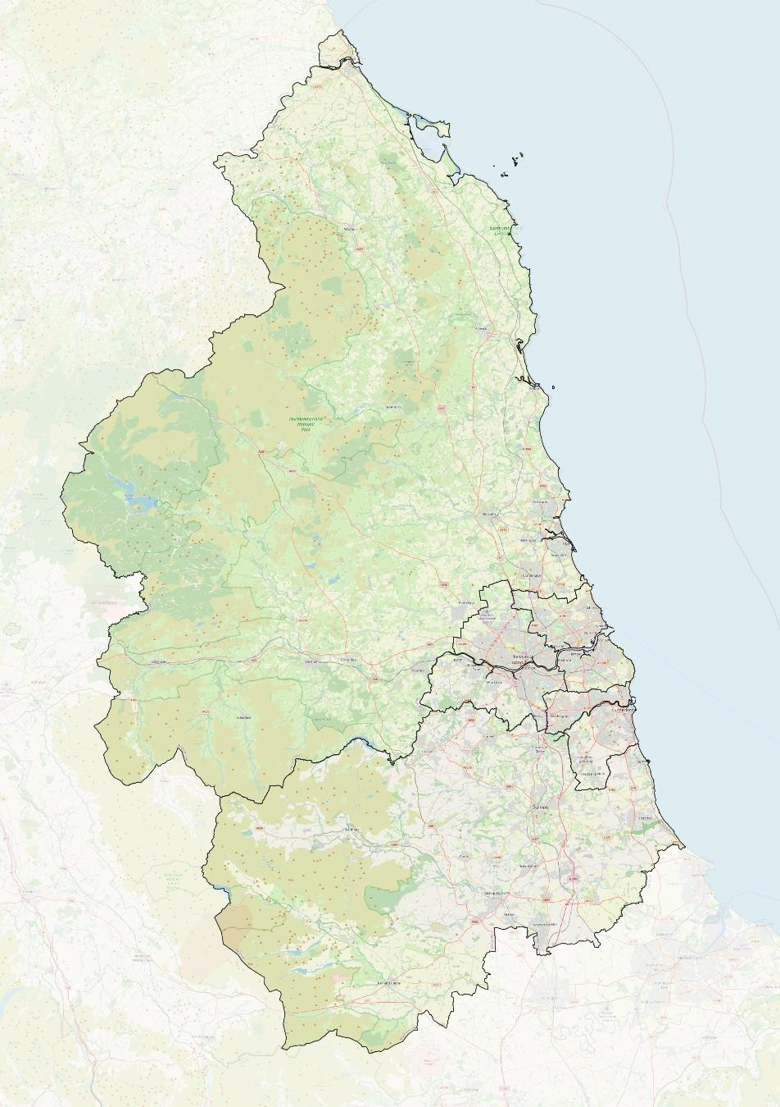

A functional economic market area
A well-developed evidence base highlights the importance of connecting residents with key employment centres, reducing journey times to improve economic and labour market outcomes. The ONS identifies four ‘travel to work’ areas which are contained within the North East area – the Newcastle/Tyneside area is the largest by number of journeys, followed by Sunderland, Durham/Bishop Auckland and then Blyth/Ashington. In addition, the travel to work areas for North Northumberland extends into Scotland.
There are strong commuting dependencies within the North East area, with over 90% of residents working in the area – making it a coherent geography to consider skills, access to employment and other labour force issues. These links are comparable to those in West Yorkshire but greater than other MCAs for example Greater Manchester (87%), South Yorkshire (85%), Tees Valley (86%), Liverpool (76%).
There are strong business relationships across the area, including a regional professional services role and supply chain clusters around key sectors, including automotive, offshore technology and health and life sciences. These strong commuting and business links make the area a natural functional geography for economic interventions.

Figure 2: Travel to work areas
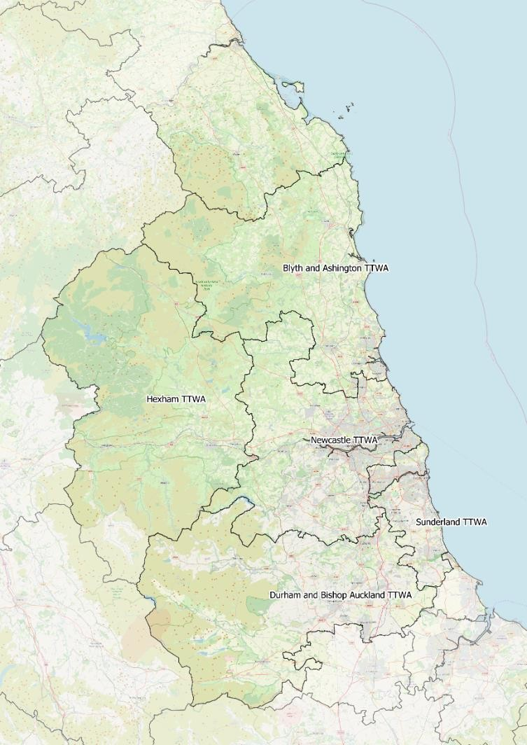
Source: ONS

Figure 3: Commuting destinations by location of residence
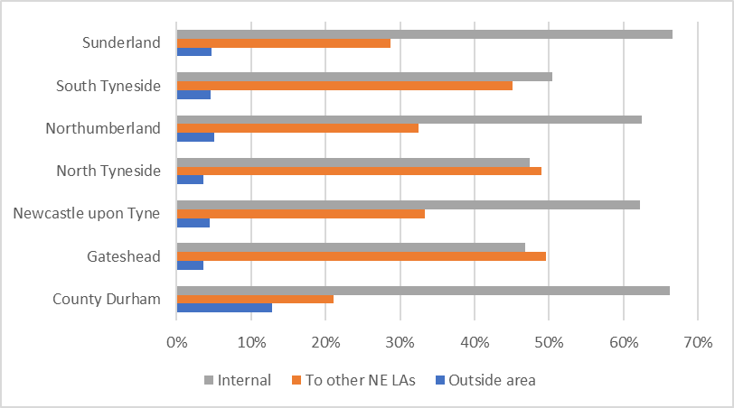
Source: ONS

North East Economy

Economic profile
Although the composition of the North East’s economy has many similarities to the national sectoral profile, there are also important differences including:
- A large, advanced manufacturing sector – including the nationally-significant automotive cluster centered around Nissan;
- An increasingly important low-carbon economy, including offshore wind technologies on the Tyne, Blyth and Wear and electrification/batteries around Blyth, Newcastle and Sunderland, and onshore wind and geothermal energy in County Durham;
- A thriving tech sector, with Sage the largest software company in the UK, Atom Bank a Unicorn Fintech company and other expertise running from consultancy to games production;
- An important leisure and tourism sector, including urban and rural assets;
- A professional services sector which is a large employer, despite accounting for a smaller proportion of employment than across the UK as a whole;
- Internationally-recognised healthcare and education assets;
- A longstanding national hub for public services, including significant HMRC and DWP assets and teams;
- Important rural and coastal economy; and
- Tourism, leisure and retail with the North East providing a diverse offer based on cities, coast and countryside.

Figure 4: Sectoral composition
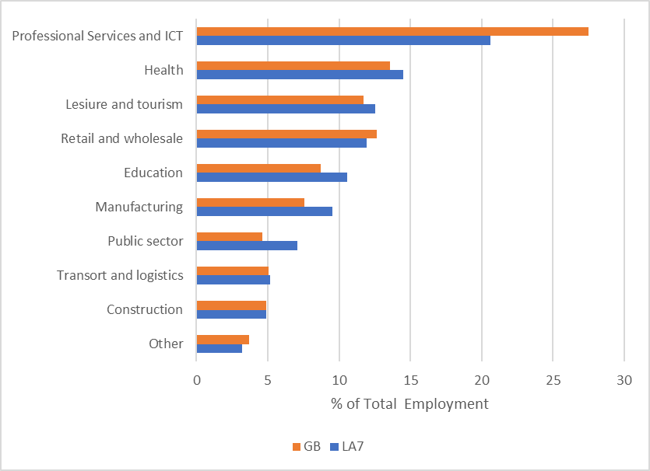

Despite its strengths, the North East has a relatively small business base, with the wider NE region having the lowest business density in the country. Micro and small businesses with under 50 employees account for 97.8% of businesses (UK, 98.1%).
A slightly greater proportion of residents are employed in large businesses of more than 250 employees, including in a number of our major manufacturing companies. And the rate of new business formation is only about three-quarters of the national average, but business scale-up rates are better. The North East has strong export performance, particularly including automotives and pharmaceuticals.
Challenges identified by our businesses include: skills shortages, replacing an ageing workforce, skills for new sectors, increasing energy and input costs, attracting more foreign direct investment and increasing innovation – where levels of private sector research and development are much lower than the national average.

Figure 5: Business density
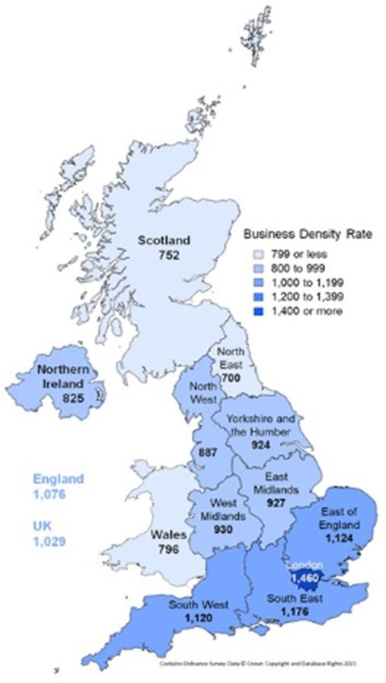

In terms of housing, on average house prices are more affordable in the region than the country as a whole. However, affordability measures have deteriorated and in several communities housing remains out of reach of many, including key, workers.
Other housing challenges include:
- Tackling the increasing challenge of homelessness
- Weaknesses in the private rented market
- Improving the quality of stock
- Bringing empty homes back into use; and
- Accelerating housing delivery on a number of brownfield sites.

Figure 6: Housing affordability (Median house price to income ratio)
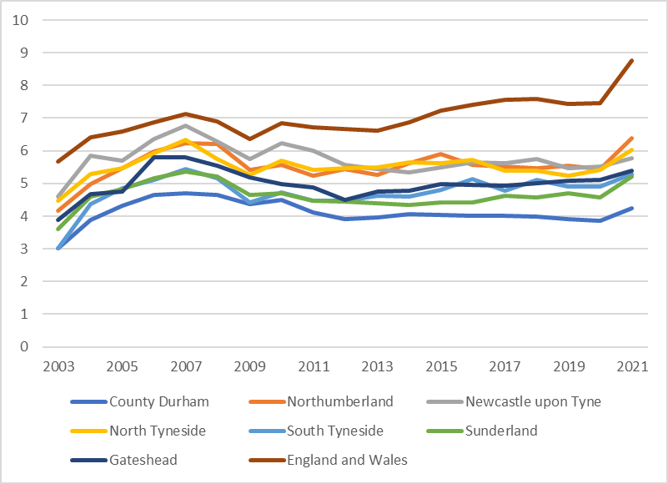
Source: ONS

Car usage continues to dominate, accounting for 60% of all journeys across the region. The North East Transport Plan sets out how the transport network can evolve in a series of lasting improvements that will shape our region in the decades to come.

The Transport Plan identifies a range of policy initiatives and investments – including a major increase in the levels of active travel through improvements to pedestrian and cycling infrastructure, improving bus travel, a region-wide electric vehicle charging network, investment in metro and local rail, and improving connections outside the region. In addition, rurality provides an opportunity for innovative transport solutions and behavioural change initiatives.
Digital connectivity varies significantly across the area. While superfast coverage in Tyne and Wear and County Durham exceeds or is in line with the national average, Northumberland is lagging with 95% superfast and 36% full fibre, compared with UK averages of 97% and 42%
There are fast rail connections to London and Scotland via the East Coast Mainline; mass rapid transit in Tyne and Wear is delivered by the Metro system which is owned and operated by Nexus (the Passenger Transport Executive) which is a public sector body that works on behalf of the Tyne and Wear councils; and the Tyne Tunnels are also a locally-owned asset linking North and South Tyneside, and making the A19 highway a long-distance strategic connection. The local authorities have a significant stake in the North’s 2nd largest airport, with links to international hubs including Heathrow and Dubai. The area has important ports – at Blyth, Tyne and Sunderland – supporting trade and industry.
There are four leading universities – Durham, Newcastle, Northumbria and Sunderland – and a strong further education network, with Newcastle College Group one of the biggest providers in the country and Tyne Coast College delivering unique maritime education and the North East Institute of Technology provides specialist training in construction, engineering, manufacturing and digital sectors.
Significant progress has been made by the North East in reducing carbon emissions, specifically from industrial and commercial sources. Overall, there has been a 56% decrease in emissions, which are now 23% lower on a per head basis than the national average. Nevertheless, further progress needs to be made on the transition to net zero, especially around transport where (with the exception of the impact of the pandemic) emissions have remained relatively little changed over the past 15 years.
The area is known for its outstanding historic, cultural and leisure assets, with the Hadrian’s Wall World Heritage site (which includes assets in Northumberland, Newcastle, North Tyneside and South Tyneside) complemented by the Durham World Heritage Site.
There are also diverse rural and coastal assets – from the Kielder Forest with its Observatory and Dark Sky status to the UK’s Beach of the Year at South Shields and the North Pennines Area of Outstanding Natural Beauty. These are backed by a strong sporting heritage, contributing to the region’s identity.

Marsden Beach, South Tyneside

Challenges
Despite these strengths, economic outcomes in the area underperform the national average. On many measures, recent improvements were reversed during the pandemic. However, in contrast to our experience with previous recessions, outcomes during the pandemic did not diverge further from the national averages.
In addition to the need to tackle climate change, we have identified five key inter- related challenges which are particularly related to the region. First, low growth and productivity, which has also held back wages. Second, average qualification levels well below national average. Third, levels of unemployment and inactivity are significantly above the national average, with outcomes notably worse for those with lower-skill levels. Fourth, lower income and higher rates of worklessness has led to significant deprivation. And this has been accompanied by our fifth challenge: poorer health outcomes.

- Lower growth, productivity and wages
Trends in the North East’s economy over the past two years have been dominated by global forces; the onset and recovery from the pandemic, and then the cost-of- living crisis, with sharp increases in energy and other costs resulting from the war in Ukraine.
But comparisons with the national picture show that the level of economic output – as measured by GVA per head which is an indicator of productivity – is significantly lower in the North East than the UK average. The gap with the ‘median’ across the country is smaller, although economic growth in the North East has been weaker over the past 15 years.

Figure 7: GVA per head (£)
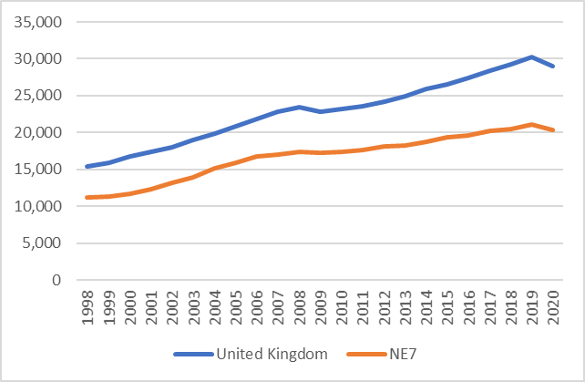
Source: ONS
Lower economic growth has also been accompanied by lower average wages, which are currently around 10% below the national average. Of the seven local authority areas, only in Newcastle are average wages close to the national average.

Figure 8 Average weekly wages
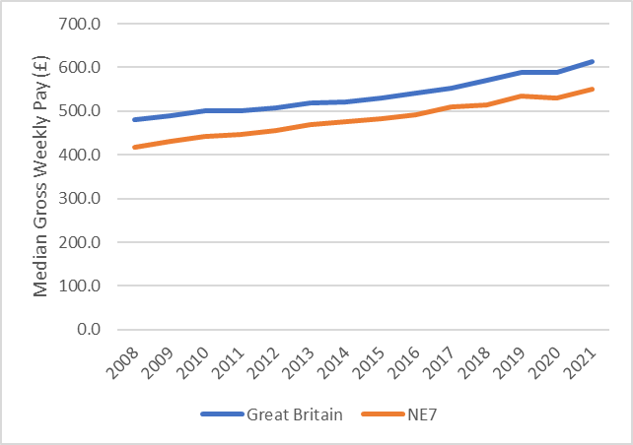
Source: ONS

- Skill levels well below national average
The North East generally performs poorly in terms of skills supply. Average qualification levels are lower than national average, with more residents with no qualifications.
This gap in qualifications is particularly pronounced at higher levels, with the number of people in the NE region with qualifications at degree level (NVQ4) or above only 80% of the national average.

Figure 9: Skill levels
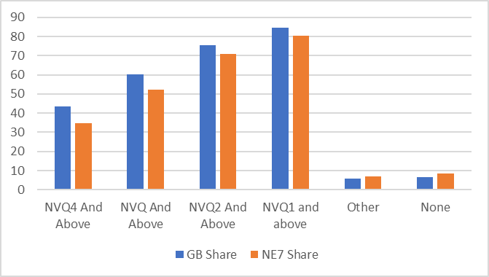
Source: ONS

- Higher unemployment and inactivity
The area has seen a strong reduction in unemployment since the height of the pandemic, with the unemployment rate falling to 5.0% in the 12 months to June 2022 from a peak of 6.9%. Nevertheless, this remains significantly above the national average.
The number of people classified as ‘economically inactive’ has increased significantly in the past two years. This category includes those who are not working and are not currently seeking a job – and includes those who are sick, students, the retired and those with caring responsibilities. The big increase in inactivity which we have seen mainly reflects people who are long-term sick.

Figure 10: Unemployment (%)
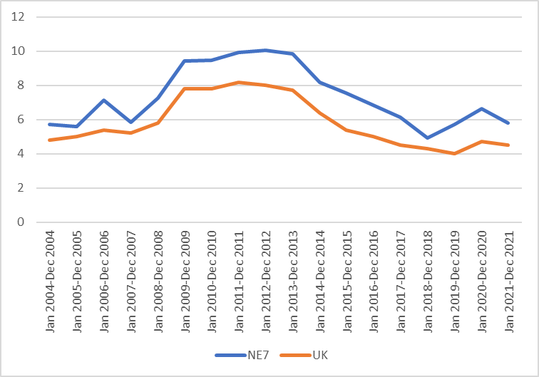
Source: ONS

Figure 11: Inactivity
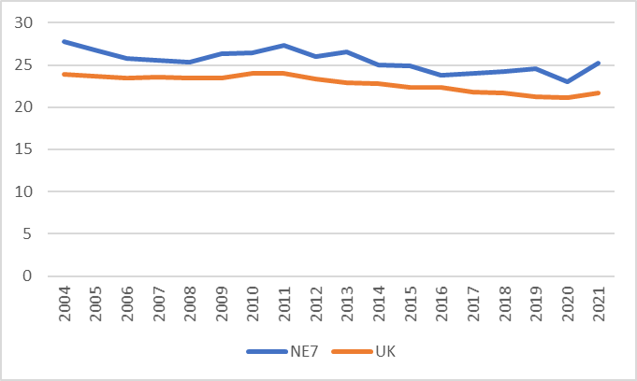
Source: ONS

- Higher levels of deprivation
Higher rates of unemployment and lower average pay result in higher levels of deprivation in the North East. In particular, there are clusters of deprivation along the banks of the Tyne and the Wear, in SE Northumberland and the Eastern towns of County Durham. This is captured in Government’s ‘Indices of Multiple’ deprivation, which are based on a weighted average of a number of different outcome measures. On this index, the North East scores worse than the national averages around measures of employment and income, but better on measures of the quality of ‘living environment’ and around the accessibility of ‘housing and local services’.

Figure 12: Indices of multiple deprivation
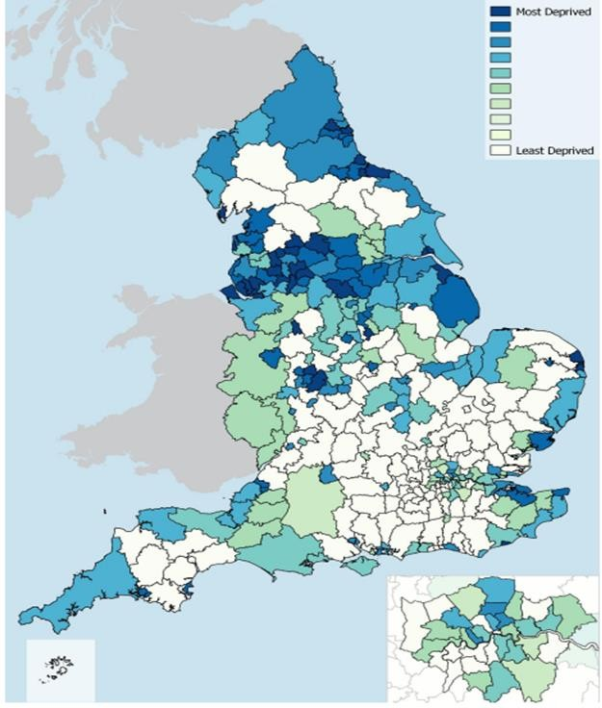
Source: ONS

- Poorer health outcomes
The North East has poorer health outcomes than the UK overall. At 79.6, the average life expectancy at birth in the North East is 1.7 years lower than the median across the UK. And this gap has increased in recent years: at the turn of the millennium the gap was 1.4 years.

In addition to being more likely to have a shorter lifespan, those in the North East spend a larger proportion of their lives in poor health. Within the region, there is substantial variation between outcomes in more deprived and more affluent areas.

Figure 13: Average life expectancy at birth
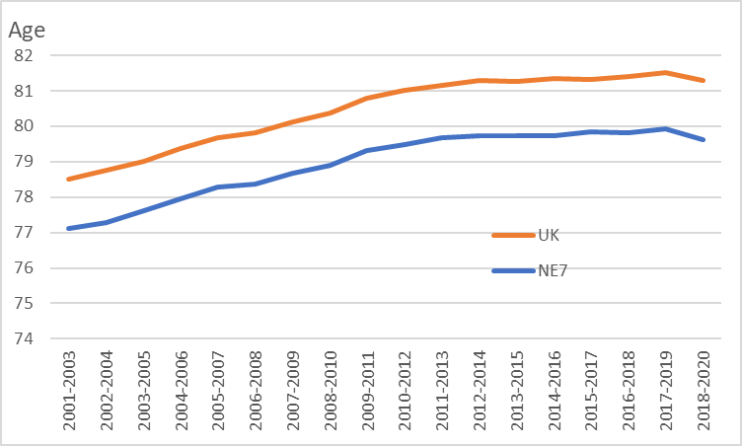
Source: ONS

Opportunities to improve outcomes
Despite the challenges, there are opportunities to improve outcomes including:
- To better-connect people to employment – taking advantage of high levels of vacancies in region by historic standards
- To improve longer-term outcomes for residents (and support the economy) through improvements to education, skills and entrepreneurship and by increasing the focus on ‘good work’
- To lead the low-carbon revolution – especially around offshore wind, geothermal energy and electrification – and to continue to attract record investment
- To improve business growth and productivity through high value-added industrial clusters, including by strengthening innovation and R&D outcomes
- To transform perceptions of region: From a relatively peripheral region with a relatively weak economy… to one which is connected nationally and
internationally by strong digital and transport links … with a strengthening economy … and which can offer outstanding quality of life – building on strength of communities, affordable housing, a resilient climate and access to outstanding rural, coastal and heritage assets.
This Governance Review is focused on how best to tackle the challenges and use those opportunities.

Understanding current governance arrangements
The proposals set out in this document are based on a strong track-record of working together across local authority boundaries in the North East. In recent years this has included through the work of the NECA and the NTCA, together with collaboration through other structures, including the Association of North East Councils, the North East Local LEP and the North East Joint Transport Committee. These organisations have had responsibility for issues spanning from the pandemic response to overseeing improvements to transport infrastructure, and from unlocking house building to the introduction of new skills programmes.

Devolution in the North East
This is a third iteration of devolution in the North East.
The first saw the creation in 2014 of a North East Combined Authority comprising Durham, Gateshead, Newcastle, North Tyneside, Northumberland, South Tyneside and Sunderland. This was established to bring together decision taking and collaboration on integrated transport and local economic development. A similar approach was taken in other places, including South Yorkshire, West Yorkshire and Liverpool City Region.
In 2016, discussions in the North East on a ‘minded to’ devolution deal ended when it became clear that the deal could not command the constituent authority consent of all 7 local authorities involved at the time.
The consequences were the adjustment of the North East Combined Authority to cover Durham, Gateshead, South Tyneside and Sunderland to continue to collaborate but without an elected mayor. And, the creation of a new Mayoral Combined Authority in November 2018, the North of Tyne Combined Authority, to cover Newcastle, North Tyneside and Northumberland. Collaboration around transport would be led through a Joint Transport Committee across the wider area.
The two Combined Authorities have been responsible for creating the conditions for economic growth and new investment in the area, with the NTCA also having additional powers and funding to support inclusive growth, housing and skills. To date, the NTCA has secured investments which will create almost 5000 jobs, half the NTCA’s 30-year target. At the same time, there has been strong collaboration between NECA and NTCA on a range of issues including:
- Development of a joint North East Transport Plan
- Management of strategic transport funding including prioritisation of the Transforming Cities Fund
- Delivery of the North East Strategic Economic Plan (2014-2024)
- Access to finance
- NE Screen Industries Partnership
- Oversight of North East LEP activities

A new Mayoral Combined Authority for the North East would be able to build on this work, overseeing over £4billion of new investment into economic growth, skills, transport and housing & regeneration.
In addition to the creation of NECA and NTCA, a Joint Transport Committee was established through which both Combined Authorities agreed to jointly exercise their transport functions. The Joint Transport Committee has developed policies, funding bids, projects, contract management, delivery programmes and partnerships covering all aspects of transport covering the whole of the North East area – that is the LA7 authorities.
Coterminous with this arrangement is the North East LEP whose board, which was established in 2011, includes political representation from across both combined authorities, together with private sector leadership and the education and voluntary sectors.
On 2nd February 2022, the Secretary of State for Levelling Up, Homes and Communities published “Levelling Up The United Kingdom” a White Paper that describes the Government’s policy intent in tackling regional disparities and inequalities. The White Paper and announcement make reference to a “County Deal” for Durham and negotiations to agree a Mayoral Combined Authority deal for the North East.

Collaboration across the North East
The “North East” can mean many things to many people. Sometimes it is the 12 local authorities which come together as the Association of North East Councils. Those local authorities work together on health and social care as part of the North East and North Cumbria Integrated Care Board (which actually covers 13, soon to be 14 local authorities) and through the North East branches of the Association of Directors of Children’s Services, the Association of Directors of Adult Social Services and the Association of Directors of Public Health. The same 12 currently host the North East Cultural Partnership and collaborate to provide elected member representation on a range of bodies who cover the entire North East from Redcar and Cleveland to Northumberland.
During the pandemic, for almost two years, 8 Leaders and Mayors (7 local authorities and the Mayor of North of Tyne) have collaborated to provide policy leadership to the response. Meeting at least weekly, they worked hard to provide a coordinated, cross-party voice to the communities they serve and on behalf of those communities into government. That leadership made a difference to the strength of the North East’s response and is now focussed on the region’s recovery.
In parallel, for the last 4 years, the same leadership group, working through a Joint Transport Committee have provided policy leadership to a Transport Plan for the North East and secured significant investment which is currently making a practical difference on the ground in the region. That group have also created a common voice to government on integrated rail planning, bus services and government support to local public transport. In particular, they have worked together to make the case for the use of the Leamside Line, upgrading the East Coast Main Line,

developing the Northumberland Line and a stronger partnership to deliver better bus services.

All of that work has created a sense of common purpose that Leaders and Mayors have sought to continue for the good of the North East.

Local Enterprise Partnerships
From 2011, local enterprise partnerships (LEPs) were established as a public-private sector partnership. There are 38 LEPs across England. They are business-led partnerships between local authorities, local private sector business leaders and education and voluntary sector senior leaders. Each is tasked with playing a central role in determining local economic priorities and undertaking activities to drive economic growth and job creation, improve infrastructure and raise workforce skills within the local area.
The wider North East served by the 12 local authorities is covered by two Local Enterprise Partnerships. One for the 5 Tees Valley authorities and one for the other 7 – the North East LEP.
The North East LEP board is led by a private sector Chair and has board members from local leaders of industry, educational institutions, the voluntary sector and local authorities. It manages multi-million-pound investment programmes designed to improve and support the North East’s economy. These include the North East Investment Fund, North East Enterprise Zones, the Local Growth Fund and the Getting Building Fund. The North East LEP leads significant programmes covering the skills and enterprise agendas, business and sectors’ growth and innovation, as well as economic data and evidence work on behalf of the region.
In March 2022, Government announced its response to a review of LEPs. That includes the intention to integrate LEP functions and roles into Mayoral Combined Authorities or upper-tier local authorities. Following discussion locally and nationally, the “Minded-To” deal includes integration of the functions and roles of the North East LEP into the North East Mayoral Combined Authority.

Transport Governance and Funding
As described earlier, the transport powers of both current combined authorities are currently exercised through the North East Joint Transport Committee. Political representatives from across the area come together to provide policy direction and governance for transport matters in line with the agreed North East Transport Plan. There are specific delegations in place to allow for Durham, Northumberland and Nexus to deliver services on behalf of the Joint Transport Committee, and a sub committee for Tyne and Wear to oversee Nexus’ delivery of services (Metro, bus and Ferry) and the Tyne Tunnels.
The North East Joint Transport Committee is responsible for overseeing over £200m of capital investment, including funding from the Transforming Cities Fund. This includes investments in active travel corridors, bus priority schemes, Park & Ride improvements and city centre public realm improvements. In addition, the £94m Metro Flow scheme will provide extra Metro track capacity in Jarrow and Hebburn,

which when combined with the introduction of a £360m new fleet of Metro trains will enable the whole system to operate at six trains per hour on each line, compared to five trains per hour at present, and to reduce delays by improving operating efficiency and resilience.
Leaders and Mayors have recently turned their attention to longer term transport
funding and the Government’s City Region Sustainable Transport Settlements. This funding is designed to support integrated transport at a regional level. In 2021, Leaders and Mayors spent time with Government Ministers making the case for delegation of £563m of transport funding to the North East via the Joint Transport Committee. Towards the end of 2021, the Government made it clear that it would only consider such a delegation through a Mayoral Combined Authority for the North East.

Case for change
As explained above, the current governance arrangements for the LA7 authorities and the different powers between parts of the area constrain access to funding. The authorities have therefore undertaken an assessment of the opportunities and challenges existing across the region, demonstrating that access to a broader range of powers and devolved funding is needed to achieve the area’s full growth potential.

The “Minded-To” North East Devolution Deal
Government and the North East local authorities have agreed an ambitious “minded- to” devolution deal that will provide the area with significant new powers and funding to increase opportunities and living standards through inclusive growth and productivity improvements. The content of the deal (included here in Annex A) has a clear focus on making a difference for people, communities and business in the North East.
The deal is described as “minded-to” as the proposals are subject to consultation with stakeholders, formal consent from each constituent council and parliamentary approval of the relevant legislation to implement the proposal over the coming months.

Governance
The economic and social challenges facing the region need to be addressed and opportunities maximised if the area is to grow and prosper. Collaboration via the North East LEP, the North East Joint Transport Committee and the example of the North of Tyne Mayoral Combined Authority have demonstrated the ability to make a difference with the right relationships, powers and investment. However, in the current governance environment that ability is limited in scope and geography.
As a consequence, there is strong evidence that strengthened governance arrangements across the North East with additional powers and funding, will deliver significant economic outcomes locally and improve the contribution of the area to the national economy.
Through the “minded-to” devolution deal, North East local authorities have the opportunity to take on greater control and responsibility for a number of key drivers of economic growth with a strong range of additional powers and funding.
Government have made it clear this opportunity does not exist within the existing arrangements.
Under the terms of the deal a North East Mayoral Combined Authority with a new directly elected mayor for the area will provide a stable and directly accountable platform for devolution of resources and a wider range of powers from central government. The MCA will exercise a broader range of functions which are contained in the deal and summarised below. However, it is important to note that no constituent authority powers are removed or replaced.
The Mayor will Chair the Combined Authority meetings while each of the 7 authorities will appoint one member to make up the Cabinet of the Combined

Authority. The Cabinet will be supported by a representative of the business community and a representative of the community and voluntary sector.
The MCA will be able to explore building upon existing collaboration to further strengthen partnership working with Tees Valley, Cumbria and south east Scotland (particularly relevant to the Borderlands work involving Northumberland County Council.) The constituent authorities will also work hard to ensure that the Mayor and Cabinet receive inclusive advice from the wider community of partners and stakeholders to shape policy and understand how action can lead to impact and outcome.
The relationship with business will be integral to the proposed arrangements. The new North East Mayoral Combined Authority will be supported to take on all of the functions and roles carried out by the North East LEP, consistent with section 10 of the guidance on LEP integration. This includes all relevant LEP assets and receipts, and the ongoing management of current and legacy local growth funding streams for the benefit of the whole region. The region shall benefit from strategic economic planning across a clear, consistent economic geography that builds on the established evidence based developed by the North East LEP.
Following the Government’s policy announcement in March 2022 on the Integration of LEPs into local democratic institutions, the Chief Executive of the North East LEP is working with constituent authorities and the current North of Tyne Mayoral Combined Authority (the LEP’s Accountable Body) to design a migration plan to move the functions and roles of the North East LEP into the proposed new MCA.
As well as carefully supporting the current North East LEP team, the critical policy issue will be the creation of the arrangements for North East businesses to provide advice and challenge to the Mayor and Cabinet. The expectation is that the North East LEP Board will turn into a “Business Board” linked to the Mayor and Cabinet and that the Chair of that Board will represent North East businesses as a non-voting member of Cabinet.
Experience in the North East LEP, the Joint Transport Committee, the North East Combined Authority and the North of Tyne Mayoral Combined Authority shows that decisions are generally made by consensus based on good quality, evidence-based, policy making. The “Minded To” deal builds on that with the Scheme for Publication showing a clear set of voting arrangements which will be enshrined in the order establishing the MCA and its constitution.
In addition, the following decisions will require the unanimous support of all Voting Members (ie the Mayor and all seven Constituent Council Members):
- Approval of, and any amendment to, NEMCA’s annual budget excluding those elements of NEMCA’s annual budget which relate to Mayoral functions;
- Approval of, and any amendment to, the setting of any levy which NEMCA shall apply to any Constituent Council;

The Mayor will be required to consult the Combined Authority on Mayoral strategies and this will be subject to the following specific conditions

- If the new MCA decides that they want to take on a Spatial Development Strategy power at a later date, then the decision to confer a duty on the Mayor to produce such a Strategy will require the consent of the members of the MCA’s Cabinet appointed by the constituent councils. Decisions on the adoption and operation of the Strategy will be on the basis of simple majority, including the mayor (5/8).
- The Combined Authority will be able to amend the Mayor’s budget if five of the voting members agree to do so; and
- The Combined Authority will be able to amend the Mayor’s transport strategy if a majority of members agree to do so.
The following decisions by the Mayor will require the consent of the Combined
Authority member, or substitute member acting in that member’s place, appointed by the constituent council in whose area the decision will apply
- Designation of any area of land as a Mayoral development area leading to the establishment, by order, of a Corporation (the consent of the relevant national park authority is also required if the land falls within the designated national park area)
- The compulsory purchase of land or building
- Any decision that could lead to a financial liability falling directly upon that constituent council; and
- Such other matters as may be contained in the Combined Authority constitution and agreed with the Mayor.

The Mayor and the Combined Authority will be scrutinised and held to account by the Combined Authority’s Overview and Scrutiny and Audit Committees. The existing Joint Transport Committee, North of Tyne Mayoral Combined Authority and the North East Combined Authority have these arrangements and the area is therefore familiar with supporting scrutiny in the context of transport and mayoral combined authority functions. Alongside all institutions with devolved powers, the new mayoral combined authority will be subject to the Devolution Accountability Framework, once it is formally agreed and announced. The Mayor and Combined Authority may also seek to enhance scrutiny and develop wider conference with all elected members in
the Combined Authority’s area to engage on key issues.

Functions
The deal acknowledges that some of the functions are already exercised within the North East via the Joint Transport Committee, the North East LEP or the North of Tyne Mayoral Combined Authority. However, the “minded to” deal consolidates those functions into one Mayoral Combined Authority; the Scheme for Publication explains the legislative underpinning to that consolidation as well as the devolution of further powers, not currently exercised in the area.

The detail of those functions and associated investment are in the “minded-to” deal at Annex A and can be summarised as:
- Finance and Investment -- providing an opportunity to deliver a programme of transformational long-term investment, including by supporting employment growth at key sites in the region such as: the innovation centres at Newcastle Helix and County Durham NetPark; the International Advanced Manufacturing Park; and port and river-side sites in North Tyneside, Northumberland, South Tyneside and Gateshead. It also seeks to continue the provision of access to finance for SMEs to scale in the region.
- Skills and Education – including by delivering the Adult Education Budget to meet local skills priorities faced by businesses across the whole region, and through a focus on education recovery to address COVID learning loss, addressing disparities and improving life chances for our children throughout their time in education.
- Innovation and Clean Energy – including through a trailblazer deal to grow the private sector at a local level, building the resilience of businesses and households in the North East to cost of living pressures, strengthening the North East’s global competitiveness and empowering local entrepreneurs.
While a bespoke ‘inclusive innovation deal’ programme will focus on
translating the region’s world class research expertise into jobs, skills and inclusive growth outcomes.
- Housing and Land – with the authority overseeing a major programme of investment in enabling works to bring forward new housing development and having broad powers to acquire and dispose of land to build houses, commercial space and infrastructure - supporting growth and regeneration.
- Transport – including responsibility for producing an area-wide transport plan; the delivery of significant local transport infrastructure through a £563m City Region Sustainable Transport Settlement and other devolved transport funds including Active Travel Fund and Bus Service Improvement Plan funding; service delivery through Durham, Northumberland, Nexus (Metro, bus and Ferry) and the Tyne Tunnels; developing ambitious plans for the improvement of bus services and the development of integrated ticketing schemes; the promotion of active travel; creating partnerships with national agencies including Network Rail / Great British Railways, National Highways and Active Travel England; and developing a region-wide electric vehicle charging network.
- Digital and Connectivity – including a focus on tackling the digital divide; supporting the smart adoption and scale-up of advanced digital service and technologies within our industries and public services; and working with Government to support the rollout of broadband and mobile infrastructure.
- Arts, Culture, Heritage and Sport – using the cultural, creative and visitor economy sectors to drive inclusive and sustainable growth, and making the most of the region's distinctive natural, cultural and heritage assets.
- Public Service Reform – exploring initiatives to improve delivery of public services including around Place-based Health and Care, Healthy Ageing and

Population Health and Prevention. In addition, the new MCA will work closely with the Police and Crime Commissioners to develop strong partnership arrangements, ensuring a joined up approach between community policing and place-based services;
- Resilience and Public Safety – with the Combined Authority having a role in local resilience, building on work of Leaders and Mayors to support the economy through the pandemic;
- Rural – with opportunities to build on the Borderlands Inclusive Growth Deal through the development of a joint plan for rural growth, stewardship and net zero; exploring issues including the rural economy, infrastructure, and rural housing and development.

The Combined Authority will take a joined-up approach to maximising the impact of these functions. One example of how this has previously been done is that the NTCA – working closely with local authority, NECA and North East LEP colleagues – is bringing forward a comprehensive programme to unlock opportunities associated with offshore wind; with simultaneous investment in sites, port-infrastructure, innovation and skills. This has helped unlock significant jobs growth in businesses including JDR Cables, Smulders Projects UK and Equinor.
The Combined Authority will also be able to take a place-based approach to development and inclusive growth – including strategic propositions which straddle multiple local authority areas. This will include building on the work which is using the re-opening of the Northumberland Line as part of a wider strategy around skills, employment, jobs and housing along a corridor running from SE Northumberland, through North Tyneside and into Newcastle. A similar approach is planned around the Leamside Line and Washington Metro Loop, along the A1 and A19 corridors in County Durham, and the Moor Farm / Seaton Burn A19 junctions on the boundary between North Tyneside and Northumberland.

Criteria
This section sets out the local and legislative criteria against which possible regional governance options are then considered.

Local policy objectives and tests
Leaders and Mayors agreed a set of policy objectives and tests at the beginning of the devolution journey which reflected their different positions and the mix of governance.
The policy objectives were
- A proposal which matches the ambition of Leaders and Mayors to make a difference for our residents, communities and economy
- A proposal where each Local Authority and each Combined Authority can see clear benefit for their place
- A proposal which contributes to the recovery of the region following the COVID19 pandemic; and
- A proposal supported by stakeholders and partners. Those tests were
- Is any proposal at least at the level of the North of Tyne Combined Authority Devolution Deal in terms of powers, cash value and flexibilities?
- Does any proposal contain sufficient additionality that Newcastle City Council, North Tyneside Council and Northumberland County Council can see the benefit of operating across a greater geography?
- Does the proposal avoid unfunded liability?
- Can we communicate the proposal effectively so that our residents, communities and businesses can understand it and make a balanced decision? And
- Do Leaders, Mayors and the Chief Officer team all feel sufficiently involved and recognise their contribution to any proposal?

Statutory tests
Section 112 of the 2009 Act provides that where one or more of the authorities which undertook the Review conclude that the exercise of the power to make an order under sections 104 to 107 of the 2009 Act would be likely to improve the exercise of statutory functions in the North East then they may prepare and publish a scheme relating to the exercise of those functions. The Secretary of State may then only make such an order if they consider that to do so is likely to improve the exercise of statutory functions in the Combined Authority’s area. In making any such order, the Secretary of State must also have regard to the need:

- To secure more effective and convenient local government for the area; and
- To reflect the identities and interests of local communities.

Governance options
This section examines the effectiveness of existing governance structures at the North East level and considers their appropriateness against that of other possible governance models. An assessment of the following three options is provide below
- Option 1 – Do nothing / business as usual

- Option 2 – Strengthen existing arrangements; and

- Option 3 – A Mayoral Combined Authority

Option 1 – Do nothing / business as usual
The existing arrangements have demonstrated several strengths.

The North East LEP has:
- Created a place for regional leadership and collaboration on economic development bringing business, local authorities and education together to coordinate policy;
- Channelled significant public investment into infrastructure, skills and business growth; and
- Provided significant analytical and policy development capability to the area since its inception.

The Joint Transport Committee has:
- Created a stable and representative body to lead the development and delivery of a North East Transport Plan;
- Provided effective governance to the multi-million-pound operation of transport across the area – particularly through the pandemic; and
- Provided leadership and decision taking on a range of significant programmes which are improving local transport, including developments of the Tyne and Wear Metro and delivery of the Transforming Cities Fund.

The North of Tyne Mayoral Combined Authority has:
- Met its targets for job creation, job protection and leveraging private investment;
- Shown policy leadership on Good Work, its Green New Deal and supporting rural growth; and

- Worked collaboratively across the area to support the development of wider devolution.

The North East Combined Authority has:
- Provided an important forum for collaboration and aligning the strategic intent of the four local authorities as a sub-region; and
- Acted in the role of accountable body for the Joint Transport Committee – employing the Transport North East officer team, managing significant grant funding, and providing support services for the transport function.

However there are drawbacks and the potential to miss opportunities by doing nothing / continuing business as usual:
- Foregoes coordination benefits of having strategic powers on skills, planning, housing economic development and transport within a single body over a wide geography;
- Risks only very limited private sector investment in region-wide transport projects, by having an unclear set of arrangements; and
- The powers and funding on offer through the North East “Minded To” Devolution Deal are conditional upon the adoption of a directly elected Mayor.

Option 2 – Strengthen existing arrangements
Following the publication of the Levelling Up White Paper and the introduction of the Bill to Parliament, Government has set out a clear framework for devolution. In addition, in March 2022, Government responded to the national review of LEPs and set out its policy intent to integrate LEP functions into MCAs. Government, via the Home Office, has been clear that only in those instances where a MCA and Police Force are coterminous, can local leaders consider combining the powers of the Mayor and the PCC.
In practical terms, this means there is limited opportunity to strengthen local arrangements.
In a national context, the North of Tyne Mayoral Combined Authority is likely to continue to be asked to take powers and investment in line with the Government’s work with all MCAs. (The devolution of Brownfield Housing and Skills Boot Camp funding are good examples.) However, this is only applicable to Newcastle, North Tyneside and Northumberland.
Locally, there are some policy opportunities. For example, Leaders and Mayors recently asked the PCC to Chair the Northumbria Combatting Drugs Partnership on their collective behalf. There are some opportunities to apply some managerial changes; creating shared spaces for the teams involved, examining the potential to share functions and teams. It is clear, these changes are not commensurate with the challenges faced by the area.
In July 2021, the then Prime Minister proposed the potential for devolution County Deals. Subsequently, some counties have pursued this model of additional powers

and investment in line with the Levelling Up White Paper and committed to a directly elected mayor or leader.
In the North East, Northumberland and Durham considered County
Deals. Northumberland County Council ruled this out as an option based on their commitment to, and satisfaction with, their participation in the North of Tyne Combined Authority. Durham County Council agreed to explore the
possibility. However, after significant local and national discussion the leadership of Durham County Council felt the additional powers and investment on offer from government were insufficient and too conditional to prove successful in delivering local policy priorities. Following this analysis, and discussion with Ministers, Durham County Council formally sought to join the emerging Minded To Deal for the North East.

Option 3 – Establishing a North East Mayoral Combined Authority
This option requires the existing governance arrangements to convert to a North East Mayoral Combined Authority.
The adoption of an MCA model of governance for the North East will enable the whole area to unlock the additional benefits of the “minded-to” devolution deal through the additional powers and funding from government. This will both extend and enhance the powers/functions currently exercised within the NTCA area.
In addition to the current arrangements, and over and above any strengthening of those arrangements, the following value is added by the whole North East region moving to a mayoral combined authority model of governance:
- The 30-year gainshare funding mechanism agreed in the deal provides a strong basis for the long-term approach needed to address the long-standing economic challenges facing the region. In this Governance Review we have identified challenges around a) low growth and productivity, (b) below average qualification levels, (c) levels of unemployment and inactivity above the national average, (d) lower income and higher rates of worklessness and significant deprivation, and (e) poorer health outcomes. Working at a regional level (including by providing a coherent framework for more localised interventions) provides the opportunity to develop approaches jointly with businesses, residents and communities at geographies which reflect business cluster, supply-chain and travel-to-work patterns. In addition, the Authority would have access to a wide range of assets and strengths over this geography – including within FE colleges, universities, catapult centres, transport hubs and business clusters.
- Access to £563m of new transport funding through a City Region Sustainable Transport Settlement, along with other transport funds agreed through the “minded-to” devolution deal with a total value of over £900m.
- An opportunity to draw together a range of other funding sources into one place under consolidated policy direction.
- Greater local accountability and decision-making power working in partnership with government and the constituent councils.

- A unified and influential voice to strengthen conversations with government, national agencies and business leaders in the development of local inclusive growth policy, strategic interventions, securing a greater share of national resources and influencing national decision making.
- Greater visibility and influence as one of the group of mayoral combined authorities with access to the initiatives and funding opportunities only available to the MCAs.
- Alignment at a strategic level across a broader range of statutory functions, including skills, planning, housing, economic development, transport and under a coherent strategy, appraisal framework and investment programme.
- Opportunity to use devolved skills funding to ensure greater alignment between educational provision and business needs.
- Closer working across the wider public sector on integrating functions and services.
- A stable and accountable platform underpinned by statutory powers to access greater devolved powers and funding delegated from government as part of future deals to enable locally devised interventions; and finally
- Making a difference for people, places and business by:
  - Serving a population of 2,003,593
  - Creating an additional 24,000 jobs
  - Building an additional 3,100 homes
  - Helping 6000 people to get “work ready” each year
  - Commissioning 70,000 courses each yet to get people good jobs
  - Taking major steps to Net Zero; and
  - Leveraging £5.0bn of private sector investment

Conclusions
To ensure the improved exercise of statutory functions across the area of the North East, adopting a Mayoral Combined Authority model of governance for the area (Option 3) is considered the best approach. An MCA for the area offers greater flexibility and accountability and, moreover, devolved powers and funding than can be provided through either continuing with the existing arrangements (Option 1) or strengthening existing arrangements (Option 2.)
The new MCA governance model, along with the additional devolved powers and
funding resulting from the “minded-to” deal, would better enable the area to pursue its objectives of promoting faster, more inclusive and cleaner growth and delivering transport system suitable for the 21st Century.
It is therefore concluded that:
- Current governance arrangements for the North East – based on two combined authorities (one Mayoral and one not) – do not represent the best model in terms of delivering the long-term ambitions of the authorities within the area for economic growth and the delivery of public services.
- There is limited practical scope for the existing governance arrangements to be meaningfully strengthened, short of adopting a mayoral combined authority model.
- A change is required to enable North East authorities to pursue their economic agenda a greater pace while continuing to collaborate with Tees Valley, Cumbria and south east Scotland in pursuit of shared economic and social objectives.
- The statutory criteria for preparing and publishing a scheme are met, i.e. the making of an order under S104 and S105 to enable the adoption of an MCA model of governance for the North East area is the best option and will be likely to improve the exercise of statutory functions in that area.
- In addition, establishing an MCA model for the North East will

  - Have a positive impact on the interests and identities of local communities – these proposals build on established regional governance arrangements and relationships, and will cover a coherent functional economic area and which represent the views and interests of local communities; and
  - Secure more effective and convenient local government by reducing complexity and streamlining the delivery of public services within the area. Where appropriate, initiatives to support businesses, residents and communities will be developed and delivered at wider geographic footprint, also enabling better alignment with the geographical coverage of other partner organisations.

It is therefore proposed that a governance scheme is published (a draft scheme is included at Appendix B) that confirms:

- A mayoral combined authority should cover the area of the North East;
- A mayor for the new north east combined authority should be elected in May 2024;
- The mayor would be a member of the Combined Authority and chair meetings of the authority;
- Each Council will appoint a member to the new Combined Authority, alongside non-voting members representing business and the community and voluntary sector; and
- The Mayor and MCA will exercise statutory functions, and hold some powers concurrently with the North East local authorities. No functions are being removed from those councils. Where existing functions currently held by North East local authorities are to be shared with the Mayor or the MCA, this must be agreed by the constituent councils.

Annex A: The “Minded To” Deal
Insert

Annex B: The Draft Scheme for Publication
Insert

