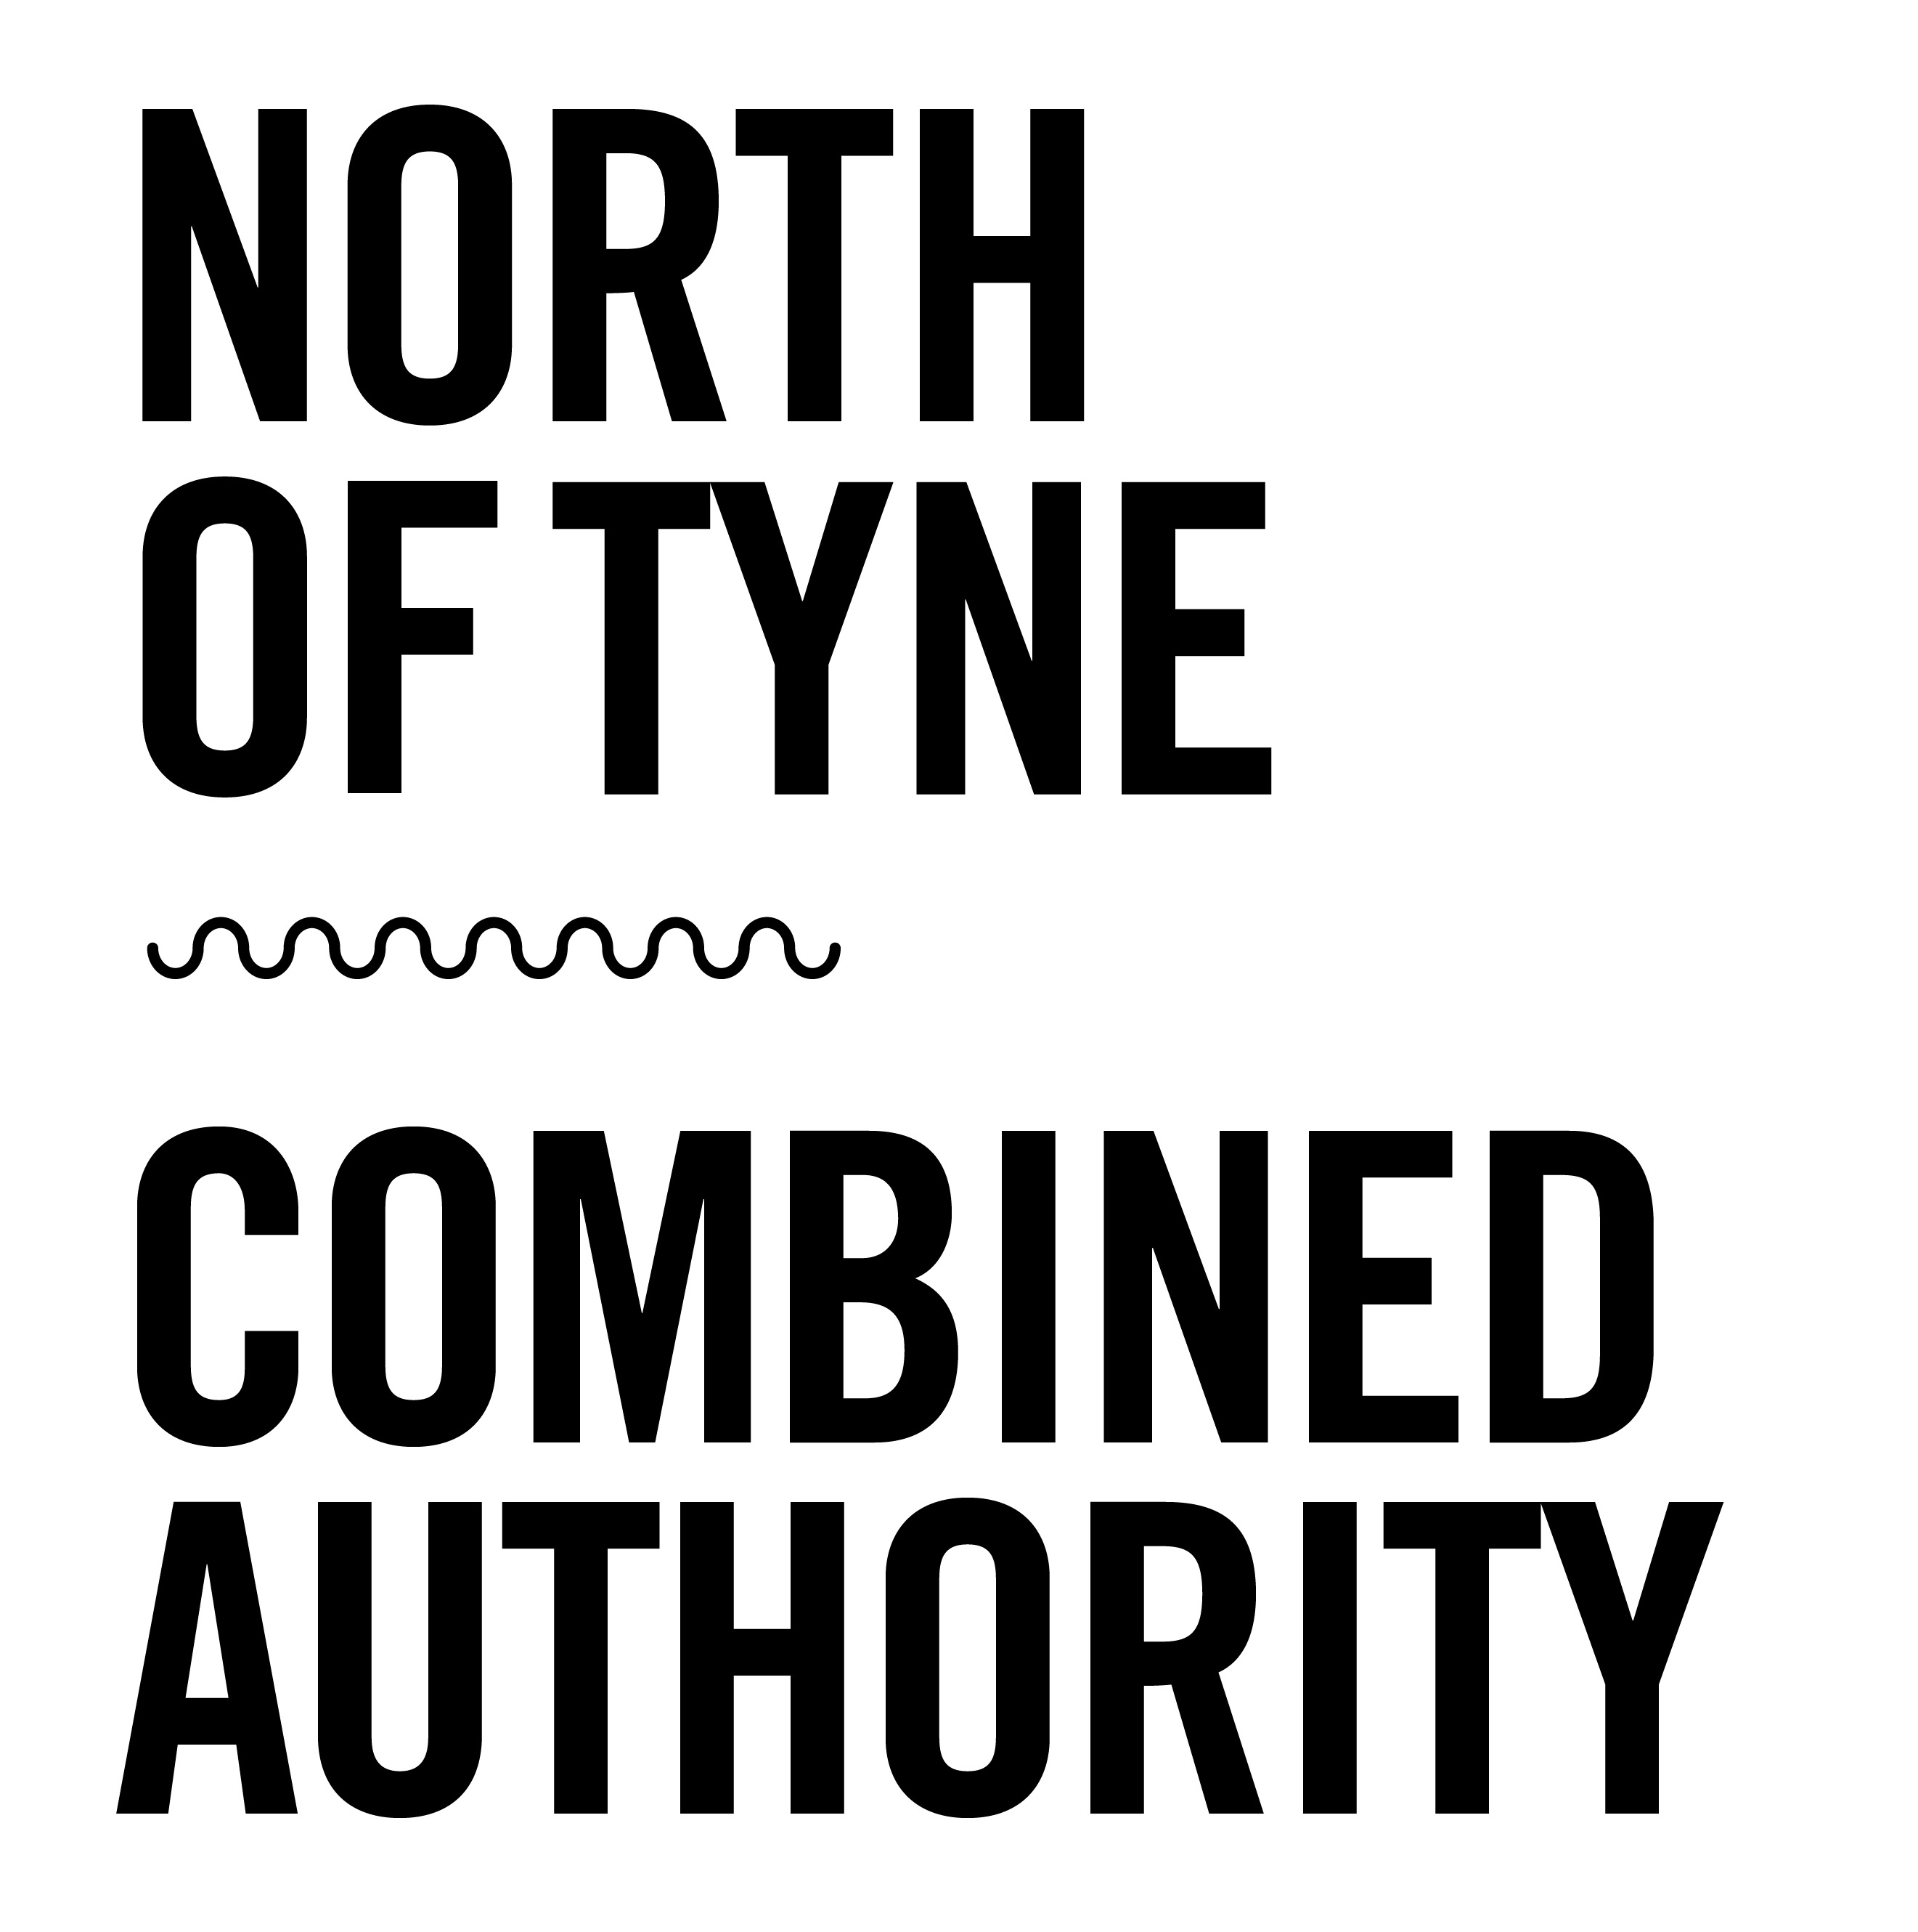

Organising inclusive events and meetings

Guidance
V1 Nov 22

North of Tyne Combined Authority: Working for everyone

All events and public meetings organised by the combined authority must be inclusive. This means that everyone must have the opportunity to attend, to be fully included and to feel comfortable and involved in the conversation while they are there.

Ensuring that no one is left out, is a key part of our ambition to build a more inclusive economy.

This document is a work in progress, and we are keen to build on this guidance and add to it over time. Please email emma.patterson@northoftyne-ca.gov.uk if you would like to suggest any additions.

Date

Plan your chosen date, time and day of the week carefully. Ensure that the date of your event doesn’t clash with any religious festivals, for example. You may also need to consider whether the working day or school holidays preclude anyone from attending. This resource from the NHS may be helpful for planning dates.

Invites

Any information you publish about the event must use appropriate and inclusive language. Language can help to build relationships and connections, but can also be a huge barrier, and terminology changes regularly. You may find this guidance from the Local Government association useful.

Consider sending invites out via multiple means (email, social media, hard copy, phone calls) to ensure they reach people from different backgrounds.

Invitations should ask about access, communication and catering requirements, as well as any other requirements, such as whether attendees need a carer in attendance, interpreter, hearing loop, BSL interpreter or easy read materials.

Please note that open/public events where attendees do not need to register in advance should consider accessibility particularly carefully, including providing a BSL interpreter as standard.

Consider providing your invite, agenda or other materials in easy read format wherever possible. This NHS guidance on creating easy read documentation is useful.

Pre-event information is essential for making sure attendees know exactly what to expect and ensuring they can arrive easily and are comfortable on the day. Consider creating and sharing an ‘accessibility guide’ which uses easy read format and alternative (alt) text for images (for those who may be blind and using a screen reader). The accessibility guide should include as much information as possible about finding the venue, entering the building, getting to the room, seating, catering arrangements and format.

Venue

In your invites you should ask specifically about access needs. Any chosen venue should be accessible as required (consider stairs and lift sizes – bearing in mind that not all lifts can fit all wheelchairs) and possible breakout rooms for prayer or feeding babies (for example).

Appropriate bathroom facilities are particularly important - accessible and disabled toilets should be available (not used as storage) and should ideally be on the same floor as the meeting.

Venues should allow for seating for guests who can’t stand for long periods.

You should consider the location carefully, ensuring that access from public transport is easy (including for those using a wheelchair or pushing a buggy, for example) and parking is available and inexpensive. You may want to consider reimbursing transport/parking costs to ensure your event economically accessible.

If you are running a series of events you may want to hold them in different locations across Northumberland, North Tyneside and Newcastle, to ensure inclusivity and representation across the region.

Ensure that there is either someone on reception or a member of staff at the entrance to welcome attendees and show them where to go.

The chosen venue should also be in line with NTCA’s values and priorities.

Catering

Speak to your caterer about inclusive catering. You should ask about dietary requirements in your invites (remembering to check requirements from staff as well). You must be able to cater for different needs and the caterer should be prepared to serve clearly labelled special meals.

You may also want to consider whether attendees can take a seat while eating and therefore whether only finger food should be provided (it’s difficult to eat with cutlery while standing).

Name badges

Consider adding pronouns to name badges.

Key-note speakers

Ensure your speakers, organisers and/or presenters are from a diverse range of backgrounds wherever possible.

Format

You should consider co-designing your event with a range of key stakeholders, to ensure it is inclusive and attendance is representative.

Any format should take into account that people absorb information in different ways and may have different tolerances for listening/looking at screens. Short comfort breaks should be incorporated.

Media

Consider neurodiversity and communication needs, including sound and lighting if you are using any technology.

Feedback

Inclusive events should ask for feedback. Attendees should be asked whether they felt the event was inclusive and this should be used to inform the design and format of future events.

Inclusive online events

Different individuals will have different requirements, but zoom is largely recognised as the most accessible platform for online meetings and has a number of accessibility features, such as captioning, which may make it easier for some attendees.

https://explore.zoom.us/en/accessibility/

If you are running an online event, you should consider your choice of platform carefully and remember to ask the same questions about communication needs (BSL interpreters may still need to attend over zoom).

Also consider that not everyone has internet access – how can those without internet at home still be included in your event?

