Transparency Information
North of Tyne Combined Authority (NTCA), including the North East Local Enterprise Partnership (North East LEP)
Contents
NTCA Land 2
NTCA Pay Multiple 3
NTCA Trade Union Time 4
NTCA Senior Officer Team 5
NTCA Senior Salaries and Responsibilities 6
North East LEP Pay Multiple 8
North East LEP Trade Union Time 8
North East LEP Senior Officer Team 9
North East LEP Senior Salaries and Responsibilities 10

NTCA Land
Serviced or temporary offices where contractual or actual occupation exceeds three months:

UPRN | Use | Site Reference | Address | Map Northerns | Map Easterns
000047224719 | Office  Land with permanent building  Leasehold 3rd floor occupied by NTCA | 09/00112/LEASEI | Quadrant West^  2 Quicksilver Way  West Allotment  NEWCASTLE UPON TYNE  NE27 0QQ | 569889 | 431312
004510736124 | Office  Land with permanent building  Leasehold Part of 1st floor occupied by NTCA | Science Central The Lumen plot 1 LA543.  A 007554 | The Lumen*, Helix, Bath Lane Newcastle upon Tyne NE4 5TF | 564261 | 424204

^ until September 2021
* from September 2021

NTCA Pay Multiple

North of Tyne Combined Authority pay multiple, defined as the ratio between the highest paid taxable earnings of an employee for the given year (including base salary, variable pay, bonuses, allowances, and the cash value of any benefits in kind) and the median earnings figure of the whole Combined Authority's workforce = 3.779
Date | Highest Paid Officer £ | Lowest Paid Salary £ | Median Salary £ | Average Chief Officer Salary £ | Pay Multiple of Highest Paid taxable earnings of an employee: Median of all other employees | Pay Multiple of Average Chief Officer Salary: Lowest paid employee
31/03/2021 | 129,564 | 19,312.08 | 38,880.08 | 119,170.50 | 3.249:1 | 6.17:1
 |  |  |  |  | 3.249 | 6.17

NTCA Trade Union Time

Trade Union Information
Trade Unions represented in the NTCA | Unison and Unite
Total number of staff who are trade union representatives | 2 (Unison)
Total number of union representatives who devote at least 50 per cent of their time to union duties | 0
Estimate of spending on unions per annum | £2,887.73
Estimate of spending on unions as a percentage of the total pay bill | 0.15%

NTCA Senior Officer Team
The North of Tyne Combined Authority (NTCA) is supported by a combination of permanently/fixed term contract employed officers who work for the NTCA and officers seconded to the NTCA from one of the Constituent Authorities.
Below is the structure chart of the senior team.

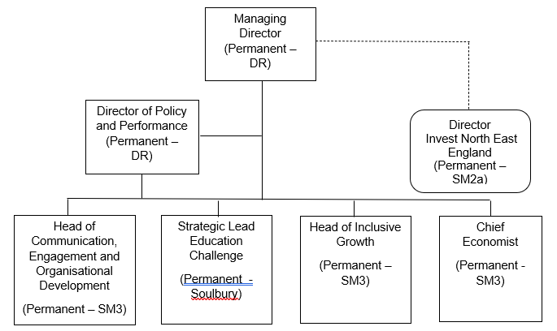
Some statutory officer roles for the NTCA are fulfilled by officers from the Constituent Authorities.
Interim Chief Finance Officer:
Head of Resources at North Tyneside Council
Interim Monitoring Officer:
Assistant Director, Legal Services at Newcastle City Council
Senior NTCA staff:
Managing Director
Director Policy and Performance
Senior North East LEP staff:
Chief Executive
The North East LEP is a partnership between senior representatives of the private, public, education and voluntary, community and social enterprise sectors and is responsible for promoting and developing economic growth in the seven local authority areas across the region. The North East LEP is not a corporate entity and so cannot hold funding and property or employ staff in its own right. It must do this through a legal entity acting on its behalf as an "accountable body". On 1 April 2020 the North of Tyne Combined Authority became the Accountable Body for the North East LEP.

NTCA Senior Salaries and Responsibilities

Job title | Service Responsibilities | Contact details | Grade | Salary ceiling | Bonus details
Managing Director | Education Challenge  Investment & Economic growth  Skills and Economic Inclusion  Rural Economy  50 staff | enquiries@northoftyne-ca.gov.uk  (0191) 2116604 or (0191) 277472 | DR | £126,096 | None
Director of Policy and Performance | Communications, Engagement and Organisational Development  Investment Programme  Policy and Performance  Governance and Scrutiny  25 staff | enquiries@northoftyne-ca.gov.uk  (0191) 2116604 or (0191) 277472 | DR | £105,866 | None
Chief Economist | Economic policy and modes of delivery  Investment pipeline and economic growth programme  14 staff | enquiries@northoftyne-ca.gov.uk  (0191) 2116604 or (0191) 277472 | SM3 | £75,780 | None
Head of Inclusive Growth | Devolution of the Adult Education Budget  Economic Inclusion  11 staff | enquiries@northoftyne-ca.gov.uk  (0191) 2116604 or (0191) 277472 | SM3 | £75,780 | None
Head of Communication, Engagement and Organisational Development | Communication and Engagement  Organisational Development  3 staff | enquiries@northoftyne-ca.gov.uk  (0191) 2116604 or (0191) 277472 | SM3 | £75,780 | None
Director, Invest North East England | Regional inward investment and marketing  (NELEP area)  3 staff | enquiries@inee.co.uk  (0191) 5197210 | SM2a | £70,124 | None
Strategic Lead Education Challenge | North of Tyne Education Challenge  Joint School Improvement Strategy  0 staff | enquiries@northoftyne-ca.gov.uk  (0191) 2116604 or (0191) 277472 | Soulbury | £60,976 | None
Principal Economy and Strategy Manager | Policy and strategy development  Sector development including Offshore & Subsea, Culture & Creative, Tourism  Rural growth  Energy, Green Growth and Climate Change  Northumberland Line Economic Corridor  Development of investment propositions  8 staff | enquiries@northoftyne-ca.gov.uk  (0191) 2116604 or (0191) 277472 | Senior Specialist  Advisor SM1 | £55,439 | None
Principal Governance and Scrutiny Manager | Statutory Scrutiny Officer  Governance and decision-making  Business Support  6 staff | enquiries@northoftyne-ca.gov.uk  (0191) 2116604 or (0191) 277472 | Senior  Specialist/  Advisor SM1 | £55,439 | None
Principal Innovation and Economy Manager | Sector development including Digital and Health Ageing sectors  Access to Finance and funding for business  Innovation  Digital Infrastructure investment  Social Economy  4 staff | enquiries@northoftyne-ca.gov.uk  (0191) 2116604 or (0191) 277472 | Senior  Specialist/  Advisor SM1 | £55,439 | None
Principal Investment Programme Manager | Programme Management & Assurance Evaluation  8 staff | enquiries@northoftyne-ca.gov.uk  (0191) 2116604 or (0191) 277472 | Senior  Specialist/  Advisor SM1 | £55,439 | None

North East LEP Pay Multiple

The North East LEP pay multiple, defined as the ratio between the highest paid taxable earnings of an employee for the given year (including base salary, variable pay, bonuses, allowances, and the cash value of any benefits in kind) and the median earnings figure of the whole Combined Authority's workforce = 3.779

Date | Highest Paid Officer £ | Lowest Paid Salary £ | Median Salary £ | Average Chief Officer Salary £ | Pay Multiple of Highest Paid taxable earnings of an employee: Median of all other employees | Pay Multiple of Average Chief Officer Salary: Lowest paid employee
31/03/2021 | 135,092 | 22,627.08 | 35,745.00 | 135,092.04 | 3.779:1 | 5.97:1
 |  |  |  |  | 3.779 | 5.97

North East LEP Trade Union Time

Trade Union Information
Trade Unions represented in the North East LEP | None
Total number of staff who are trade union representatives | None
Total number of union representatives who devote at least 50 per cent of their time to union duties | 0
Estimate of spending on unions per annum | £0
Estimate of spending on unions as a percentage of the total pay bill | 0%

North East LEP Senior Officer Team

Below is the structure chart of the senior team.

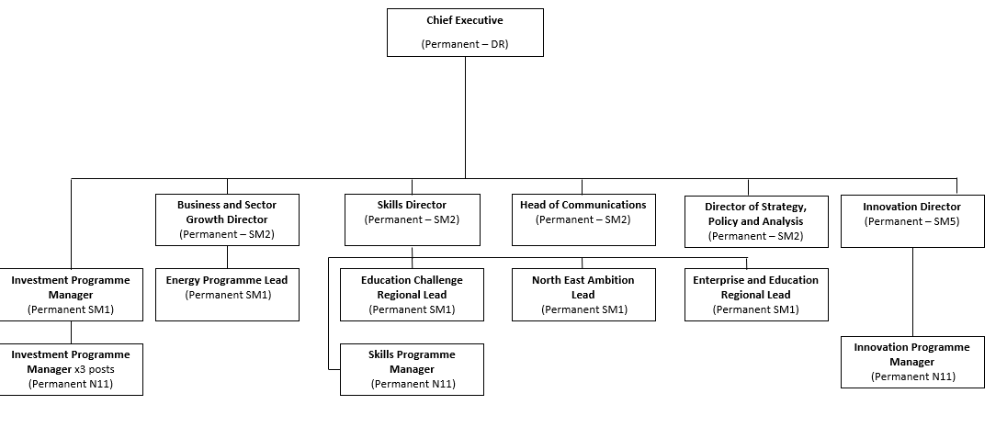

North East LEP Senior Salaries and Responsibilities

Job title | Service Responsibilities | Contact details | Grade | Salary ceiling | Bonus details
Chief Executive | Overall strategic and organisational responsibility for development and delivery Investment Programme  Policy and Performance  Governance and Scrutiny  74 staff | Info@nelep.co.uk  (0191 561 5420) | Director | £135,092 | None
Business and Sector Growth Director | Business Growth programme  Sector development (HLS, Energy and Digital)  Growth Hub  Made Smarter  Peer Networks  High Potential Start up programme  Business Support  21 staff | Info@nelep.co.uk  (0191 561 5420) | SM2 | £70,124 | None
Skills Director | Skills programme  North East Ambition  Education Challenge  ONE Vision  Enterprise Advisor Programme  Kickstart  T-levels  23 staff | Info@nelep.co.uk  (0191 561 5420) | SM2 | £70,124 | None
Innovation Director | Innovation programme and partnerships  Innovation Challenge programme  Innovation project pipeline  3 staff | Info@nelep.co.uk  (0191 561 5420) | SM5 | £94,024 | None
Head of Communications | Internal and external PR, communication and engagement  3 staff | Info@nelep.co.uk  (0191 561 5420) | SM2 | £70,124 | None
Strategy, Policy and Analysis Director | Economic strategy and policy development  Research and analysis  5 staff | Info@nelep.co.uk  (0191 561 5420) | SM2 | £70,124 | None
Investment Programme Manager | Fund Management  0 staff | Info@nelep.co.uk  (0191 561 5420) | SM1 | £55,438 | None
Education Challenge Regional Lead | North East Education Challenge  Opportunity North East Vision  6 staff | Info@nelep.co.uk  (0191 561 5420) | SM1 | £55,438 | None
Energy Programme Regional Lead | North East Energy Programme  Energy catalyst  Energy Accelerator  3 staff | Info@nelep.co.uk  (0191 561 5420) | SM1 | £55,438 | None
North East Ambition Regional Lead | North East Ambition programme  4 staff | Info@nelep.co.uk  (0191 561 5420) | SM1 | £55,438 | None
Enterprise and Education Regional Lead | North East Enterprise Advisor Programme  Kickstart  T-levels  0 staff | Info@nelep.co.uk  (0191 561 5420) | SM1 | £55,438 | None
Programme Manager | Fund management | Info@nelep.co.uk  (0191 561 5420) | N11 | £50,938 | None
Programme Manager | Innovation programme | Info@nelep.co.uk  (0191 561 5420) | N11 | £50,938 | None
Programme Manager | Skills programme | Info@nelep.co.uk  (0191 561 5420) | N11 | £50,938 | None
Programme Manager | Fund management | Info@nelep.co.uk  (0191 561 5420) | N11 | £50,938 | None
Programme Manager | Fund management | Info@nelep.co.uk  (0191 561 5420) | N11 | £50,938 | None

The North East LEP employees are included in the overall NTCA pay multiple as the North East LEP is not a corporate entity – see page 8 for more information.

