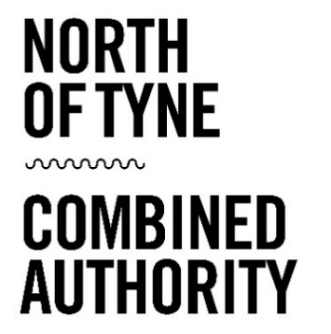
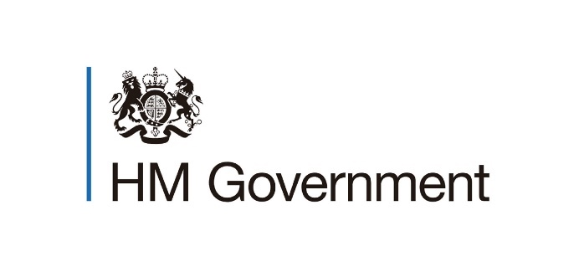

CALL FOR SCHEMES
NORTH OF TYNE BROWNFIELD HOUSING FUND
INFORMATION PACK FOR APPLICANTS
SEPTEMBER 2021

Lead Organisation: | North of Tyne Combined Authority (NTCA)
Fund Details: | MHCLG Brownfield Housing Fund
Eligible Locations: | Newcastle upon Tyne  North Tyneside  Northumberland
Call Opens: | Monday 13th September 2021
Call Closes: | Friday 15th October 2021 at 25:59 hours
Contact Details for Queries and Applications: | Housing@northoftyne-ca.gov.uk

- Introduction
The purpose of this expression of interest call is to support the North of Tyne Combined Authority in developing its pipeline including for the North of Tyne Brownfield Housing Fund programme.
This document sets out the parameters for the call and explains the process, eligibility criteria and the indicative timetable.

- Context
In the 2020 Budget, the Chancellor announced a £400 million Brownfield Housing Fund (BHF) for Mayoral Combined Authorities to unlock stalled Brownfield sites. This funding will run over a five-year period, with expenditure to be defrayed by no later than the 31st March 2025. NTCA was awarded £23,853,618 to unlock between 1500 and 2500 new homes.
Since the announcement of funding, NTCA has worked with partners to develop a programme of brownfield sites and a number of proposals have progressed to delivery.
In order to support delivery of the current programme but also to prepare for future opportunities we are seeking additional proposals through this call process. Proposals are welcomed from any private sector, charitable body, or Registered Provider.
- Call for schemes
For this call we are particularly interested in developing the pipeline of brownfield housing sites to support the development of our Brownfield Housing Fund Programme.
Schemes must be:
- Located on brownfield sites
- Green book compliant with a minimum BCR floor of 1
- Demonstrate proven market failure and could not happen without the financial support of the fund
- Achieve additionality
- Start on site by 31 March 2025
- Included in an updated or emerging local plan
- Compliant with UK Subsidy Control (Former State Aid)
- Create synergies with other government funds where applicable
- Use local SMEs / supply chains where possible

All levels of funding will be considered.

- Eligible Works

The Brownfield Housing Fund programme is strictly for enabling stalled sites to be brought forward for development. Eligible capital expenditure includes (but is not limited to):
- Site assembly
- Site clearance
- Remediation
- Service connections/diversions
- Highway infrastructure

Brownfield Housing Fund can be used in conjunction with other government funding programmes (such as the Homes England Affordable Homes Programme) but cannot be used to fund the construction of homes.

All funding must be defrayed by 31 March 2025.

Proposals are particularly welcomed that contribute to NTCA’s wider priorities, including affordable housing, community-led housing, and the use of Modern Methods of Construction (MMC). Applications are also encouraged from schemes with an accelerated spending profile.

- Submission Requirements

Project sponsors must provide the following:
- Completed expression of interest form
- Development Appraisal

To request an expression of interest form please contact Housing@northoftyne-ca.gov.uk.

Project sponsors should be aware that queries will be anonymised and all those who have requested an expression of interest form will be informed of query responses.

Completed forms and associated information are to be submitted via email no later than 23:59 on Friday 15th October 2021 to: Housing@northofyne-ca.gov.uk.

- Scoring Criteria

Proposals will be assessed on the suitability of the scheme in relation to the Brownfield Housing Fund requirements and the Green Book Business Case.

NTCA will use appointed consultants to carry out a gateway assessment of shortlisted applications. This is detailed as follows:

Information Collection
The purpose of the expression of interest form is to collect outline information for each scheme. This template is in line with the prioritisation framework and Green Book business case to allow a more robust scoring as described below.

Gateway Criteria
In order each scheme to be scored it is required to pass all the gateway criteria which are based on the fund requirements.
This includes:
- Robust evidence of market failure.
- An assessment of the scheme’s eligible costs.
- An initial BCR calculation of at least 1. This is based on the ratio between the Land Value Uplift (LVU) and the public funding required. LVU captures the difference the existing use value and the value of land once the scheme is developed.
- BHF to be spent during the 5 year period with the development of the scheme also starting by March 2025.
- Schemes that use private funding must also pass a Subsidy Control test.
- An assessment of the scheme’s strategic fit (in conjunction with Local Authority Housing leads where necessary)

Further questions and/or workshop sessions with project sponsors, consultants and local authorities may be held at this stage.

Scoring and Weighting
Schemes passing the gateway criteria are then scored as follows:
- Schemes are scored against 35 questions covering elements under each of the five cases as stated in the Green Book Business Case guidance. Each question gets a low, (1) medium (5) or high (9) score. These scores are then weighted, based on their importance for the case in order to provide a single score for each case which varies from 1 to 9.
- The scores of each case are then aggregated to provide the Total Score for each scheme (1-45).
- Finally, the Total Score of each scheme is used alongside the schemes’ Initial BCR and the number of units to be delivered to provide the final weighted score with 1 being the highest.

Further questions and/or workshop sessions with project sponsors, consultants and local authorities may be held at this stage.

- Next Steps

Schemes which pass the gateway process will be prioritised and will be formally added to the brownfield housing programme pipeline which the NTCA Investment Panel and NTCA Housing and Land Board will consider. NTCA will notify project sponsors of the outcome by the end of December 2021

Schemes with the highest final weighted scores will be invited to progress to full business case. All project sponsors invited to full business case will be required to submit subsidy control advice prior in advance of the completion of the business case.

- Indicative Timescales

Call Opens - Monday 13th September 2021
Call Closes – Friday 15th October 2021 at 23:59 hours
Scoring – Commences Monday 18th October 2021
Project Sponsors Notified – By December 2021

- Other Information

The acceptance of an expression of interest form and an invitation to progress does not in any way indicate or constitute an offer of grant support. Any costs incurred in submitting an application are at the applicant’s own risk.

Successful project sponsors must be legally constituted and able to enter a binding contract with the NTCA and will carry the liability for ensuring that the terms of the Funding Agreement are met by all delivery partners. In the case of consortia or partnership applications, a lead organisation must be identified as the Applicant. It is this organisation that carries the responsibility and liability for carrying out the project.

NTCA funding is paid quarterly in arrears against actual project expenditure. Costs must be able to be fully evidenced through a robust audit trail and be necessary for delivering the scheme.

The North of Tyne Combined Authority will take swift action against any recipients who have deliberately manipulated records or have committed fraud. Any beneficiaries caught falsifying their records to gain grant funding will face prosecution and any funding or grants paid in error will be subject to claw back.

