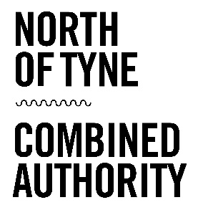

Kickstart Scheme
North of Tyne Combined Authority
How to apply:
The North of Tyne Combined Authority are assuming the role of Gateway acting on behalf of our Local Authorities to support businesses and charities to access the Kickstart scheme.
The Combined Authority will use a two-stage application process to gather the information required to apply to the Department for Work and Pensions. The expected milestones and timescales for employers are outlined below but are subject to change.
From the Expression of Interest stage to recruiting a candidate, the process takes approximately 10-14 weeks, and a minimum of 8. Please consider these timescales when planning how you engage with the scheme.
Step | Activity | Timescales
1 | Employer submits an Expression of Interest form to NTCA via the link on our website.  https://forms.gle/nexAXRHVrfypTBpd8. | Expressions of Interest will be acknowledged within 3 working days.
2 | Employer submits a detailed second stage application to NTCA providing further detail on the Placements to be created. | Second stage application forms will be issued within 5 working days from receipt of the EOI. Received forms will be acknowledged within 3 working days.
3 | NTCA will submit a formal application to DWP on behalf of the employers who have completed the stage 2 application. This will happen monthly subject to demand. | DWP has committed to informing Gateways of a decision within 30 days of application.
4 | If the application to DWP is successful, NTCA will contract with employers to agree the funding amount and requirements under Kickstart. | NTCA will issue employers a contract outlining the funding and conditions within 2 weeks following notification from DWP.
5 | Details of the Kickstart Placements will be sent to the local JobCentre Plus sites and Work Coaches will begin to advertise with young people. | NTCA will inform employers that vacancies have gone live within 10 working days of vacancies being advertised.

Our enhanced offer:
In acting as a Gateway, the Combined Authority will use its convening power to ensure that enough Kickstart placements are available in our area, that they are in sectors with actual job vacancies, and are of quality in line with the expectations of the NTCA Good Work Pledge.
To increase the value of our offer, we have also contracted Newcastle Futures as a delivery organisation to provide additional, expert support for you and your Kickstart employee.
Newcastle Futures will support you in every step of your Kickstart journey, providing an expert employability service at no extra cost to you. Their work will begin as soon as you make your decision to employ your Kickstart employee, continue throughout the placement at a frequency that works for you and your Kickstart employee, and end with 2 weeks of support after the placement has ended. They will connect with your employee and understand their needs, working to ensure that their placement is a useful, rewarding experience, as well as connecting with the employer and working to prepare clients for their journey into work. Alongside this they are aware of other services that might be helpful to you when you are agreeing the training plan for your Kickstart employee, such as training providers in various sectors or wider support services. Newcastle Futures experienced service will bring added value on top of the governments core Kickstart offer, meaning everyone who is involved in the scheme will benefit as much as possible.

